BLTPortlet log4j 2.25.5 Upgrade – Test Evidence
Oct 6, 2026 · @Satish

Change summary
BLTPortlet (Blue Licensure Tool Admin UI) was upgraded from log4j 2.17.1 to 2.25.5 to remediate the log4j security vulnerability. After deployment, the portlet loads and all list, view and form pages work in PROD.
Item | Detail
Application | BlueWeb (Liferay DXP 7.4)
Module | BLTPortlet (WAR portlet)
Page | /blue-licensure-tool
Git branch | BLTportlet_log4jfix
log4j version | 2.17.1 → 2.25.5 (log4j-api, log4j-core)
Files changed
- build.gradle — log4j-api and log4j-core set to 2.25.5 as implementation; log4j-web and duplicate compileOnly log4j entries removed.
- WEB-INF/liferay-plugin-package.properties — added -removeheaders=Bundle-Activator so the log4j jars' OSGi activators are not merged into the portlet manifest.
- WEB-INF/web.xml — removed Log4jServletContextListener, log4jServletFilter and its filter-mapping (they required log4j-web).

PROD test results
All 5 PROD test cases passed on bluewebportal.bcbs.com/blue-licensure-tool. Each page rendered with data and no errors.
# | Test case | Expected result | Result
1 | Open Blue Licensure Tool page | Portlet renders with left navigation and welcome text | Pass
2 | List Groups | Groups Data Table loads with Group Code, Description, Edit/Delete | Pass
3 | List Licensees | Licensees Data Table loads with Lic. Number, City/State, Legal Name, License Type, Business Type | Pass
4 | List Standards | Standards Data Table loads with Lic. Super Type, Title, Sequence | Pass
5 | Add New Licensee | Licensee form loads with General, Geographic and Names sections | Pass
TC1 — Portlet home
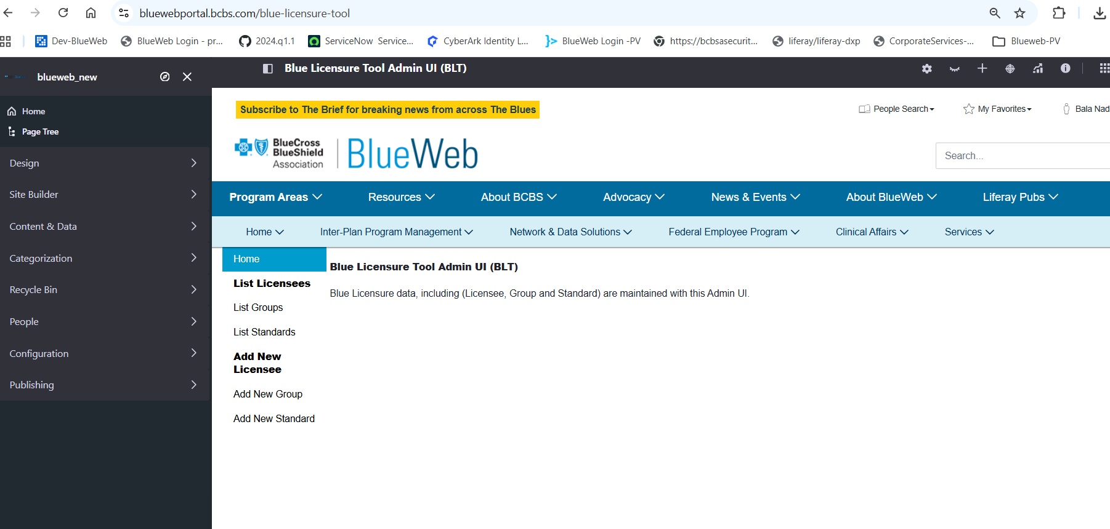
TC2 — List Groups
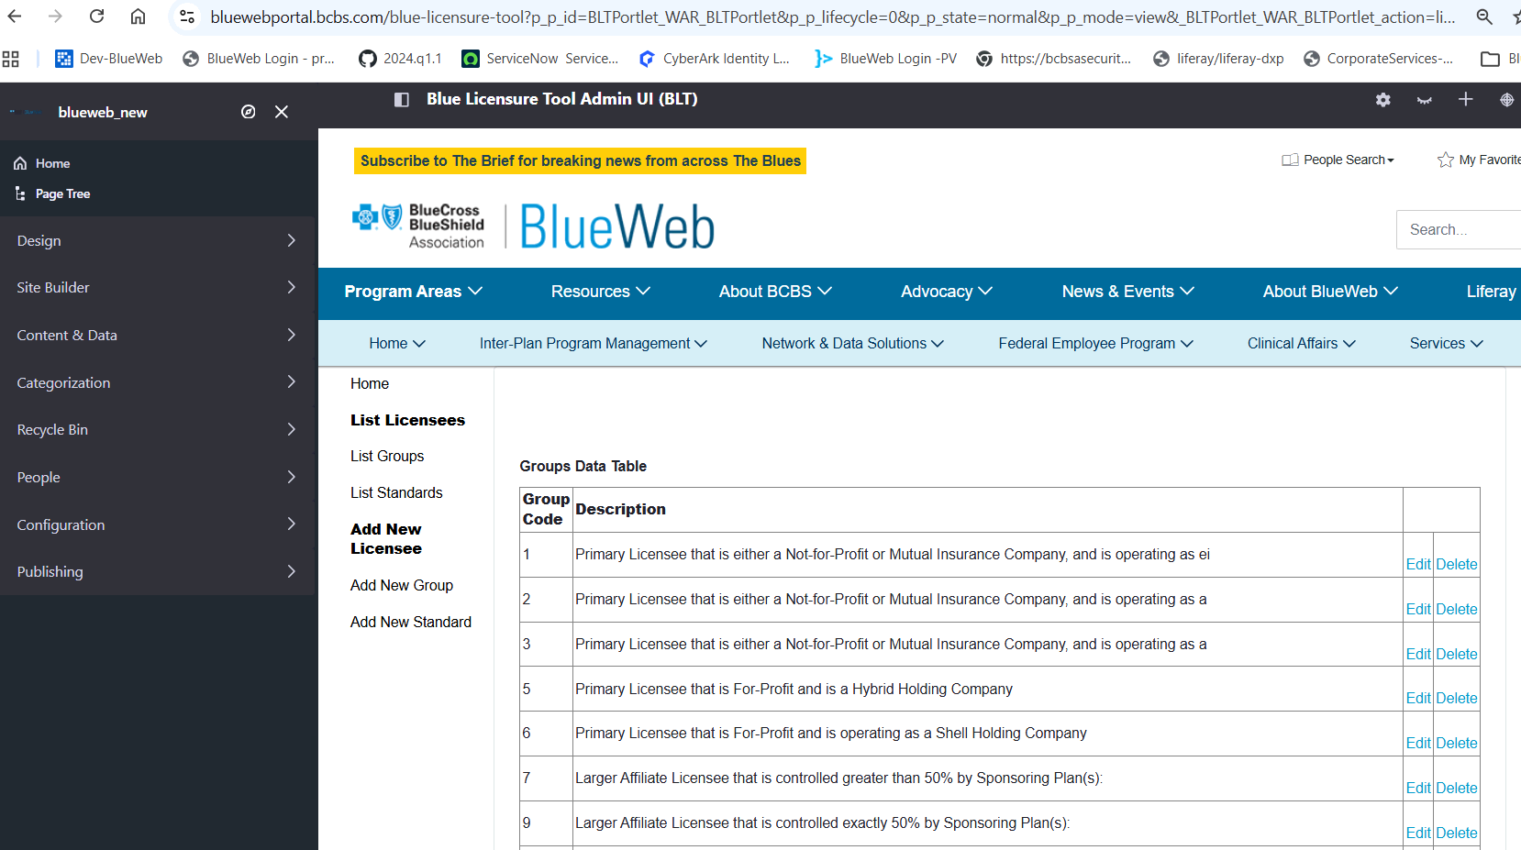
TC3 — List Licensees
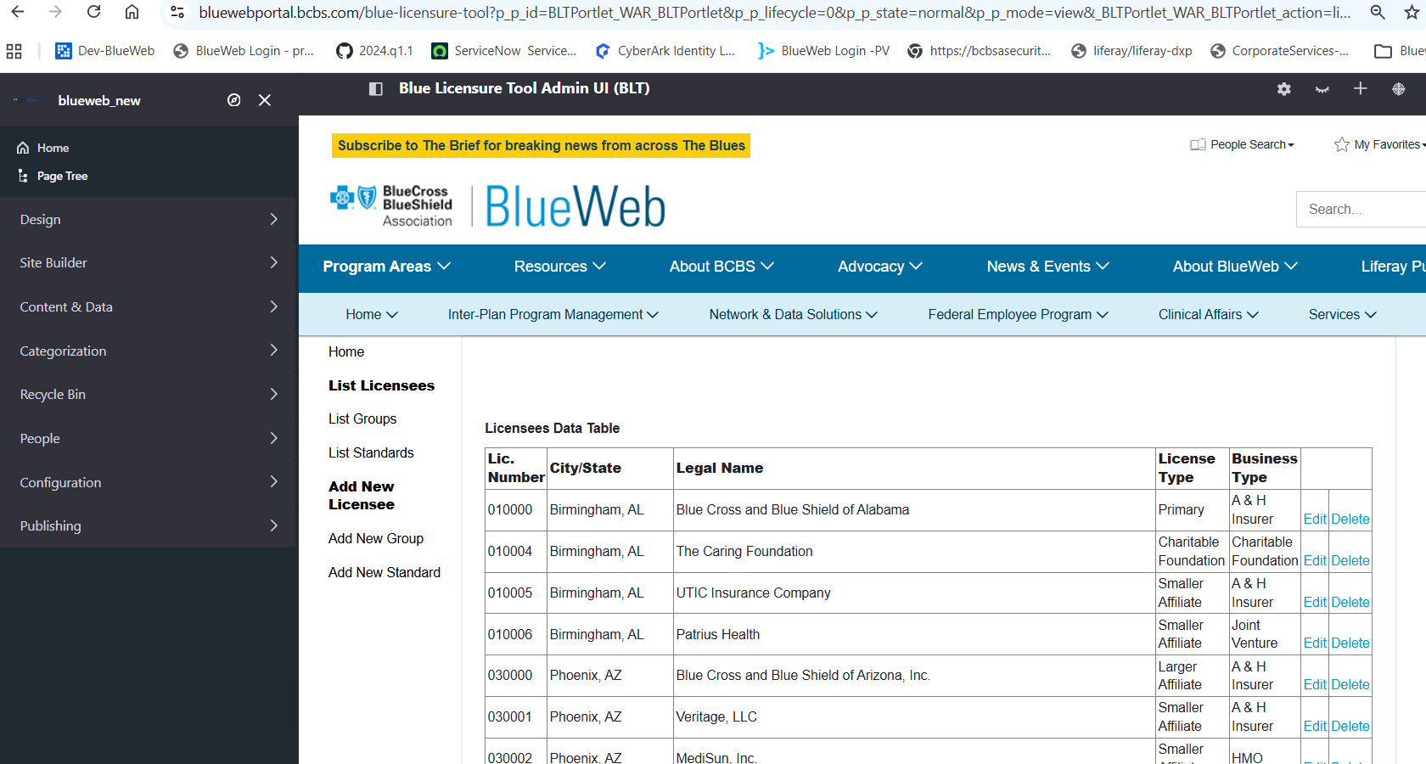
TC4 — List Standards
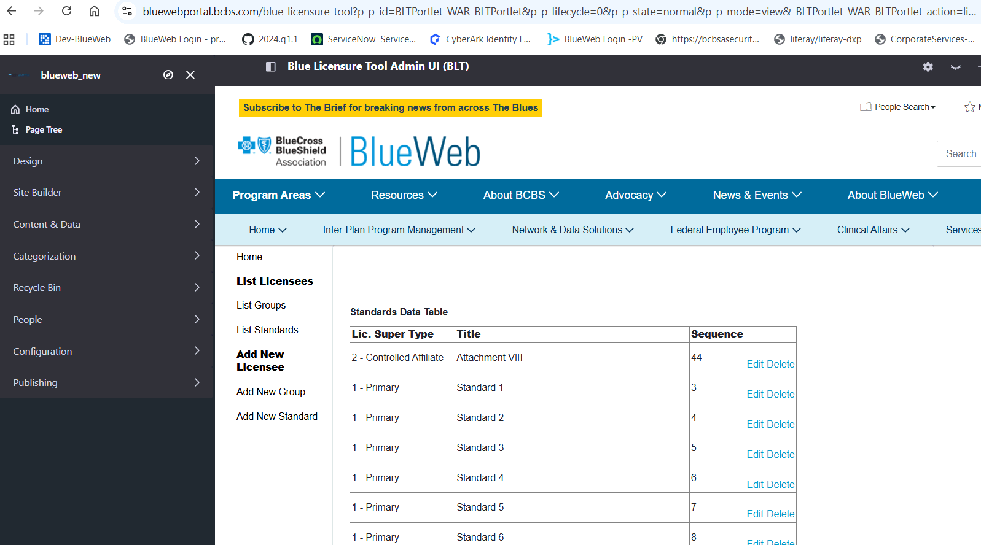
TC5 — Add New Licensee
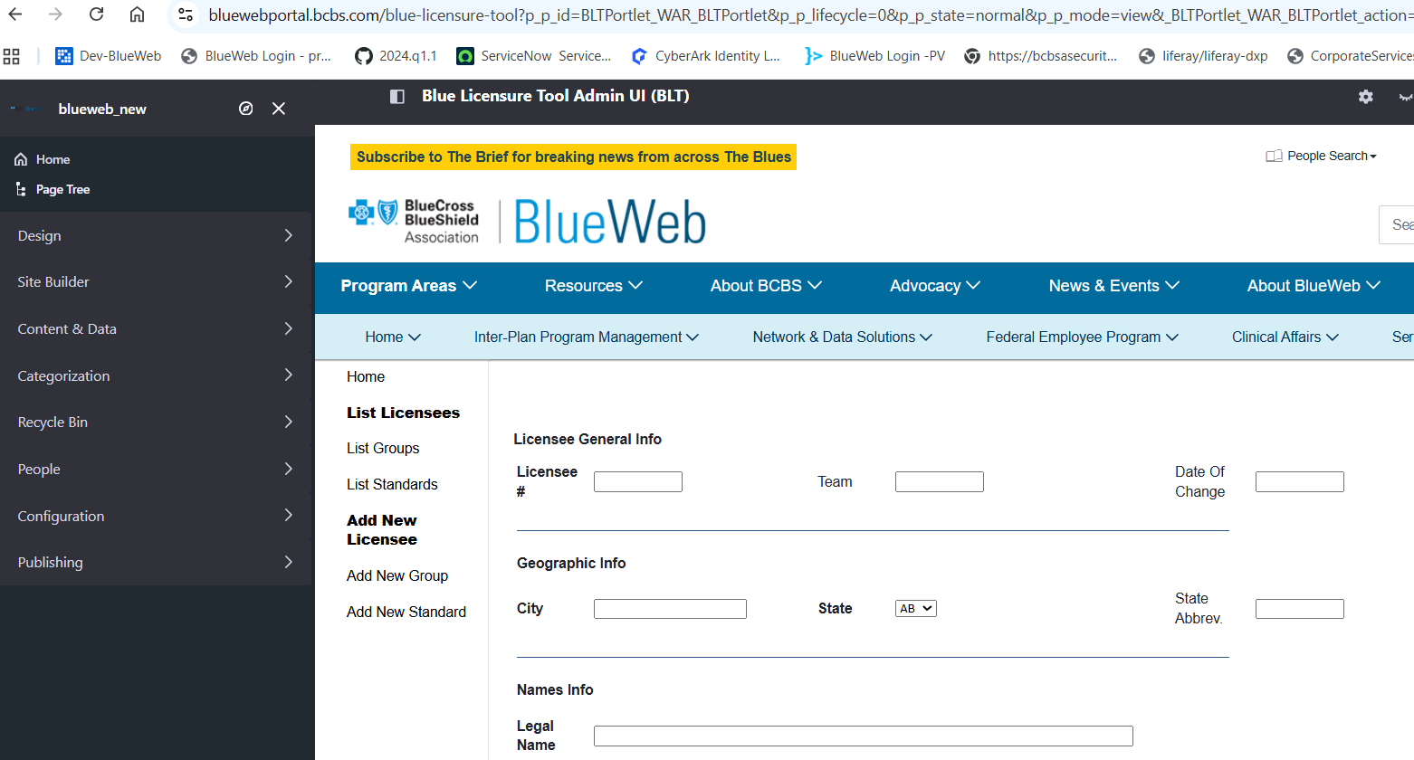

PV test results
The portlet home page loads in PV on bluewebportalpv.bcbsa.com/blue-licensure-tool. Run TC2–TC5 in PV and add screenshots before closing.
# | Test case | Result
1 | Open Blue Licensure Tool page | Pass
2 | List Groups | To be tested
3 | List Licensees | To be tested
4 | List Standards | To be tested
5 | Add New Licensee | To be tested
TC1 — Portlet home (PV)
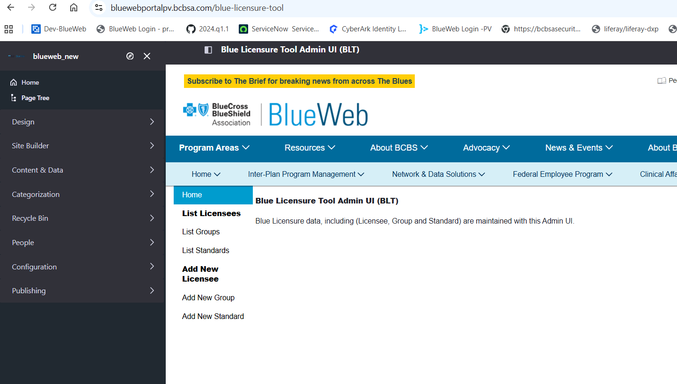

Technical verification
The bundle deployed and started cleanly in the test environment; repeat the checks on each PROD node and record the result.
Check | Command | Expected | Result
Bundle state | Gogo: lb BLTPortlet | Active | Active (test env)
No inherited activator | Gogo: headers <bundleId> | No Bundle-Activator header | Confirmed (test env)
Deploy log | catalina.out | 1 portlet for BLTPortlet is available for use, no BundleException or HotDeployException | Confirmed (test env)
log4j jars in deployed WAR | unzip -l osgi/war/BLTPortlet.war | grep -i log4j | Only log4j-api-2.25.5.jar and log4j-core-2.25.5.jar | To record per PROD node
No log4j-web / 2.17.1 jars | Same as above | None present | To record per PROD node

Conclusion and sign-off
BLTPortlet is working as expected in PROD after the log4j 2.25.5 upgrade, with no functional regressions found. Rollback, if ever needed, is redeploying the previous WAR built with log4j 2.17.1.
Role | Name | Date
Tested by | Satish | 2026-10-06
Reviewed by
Approved by | Lavanya Chimata

